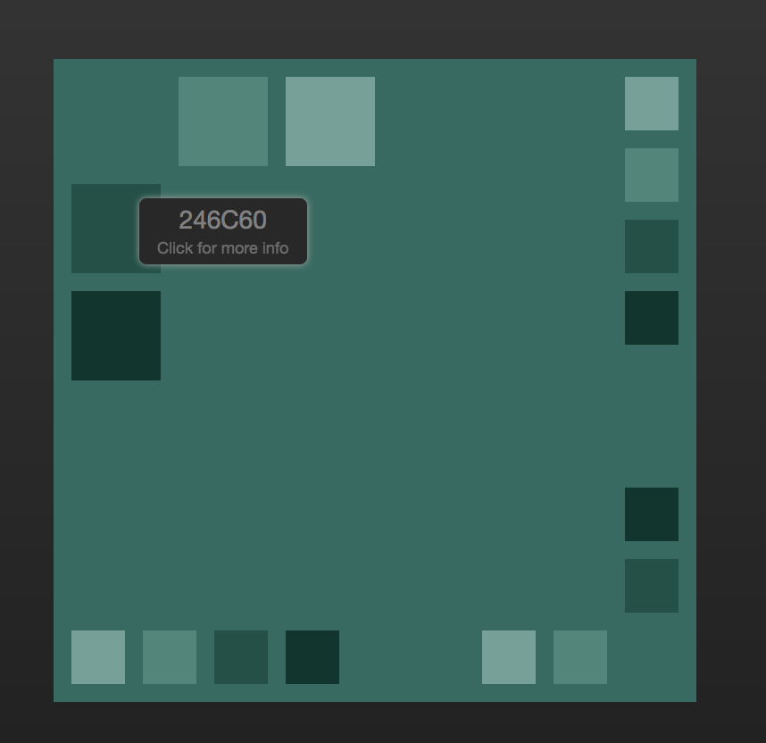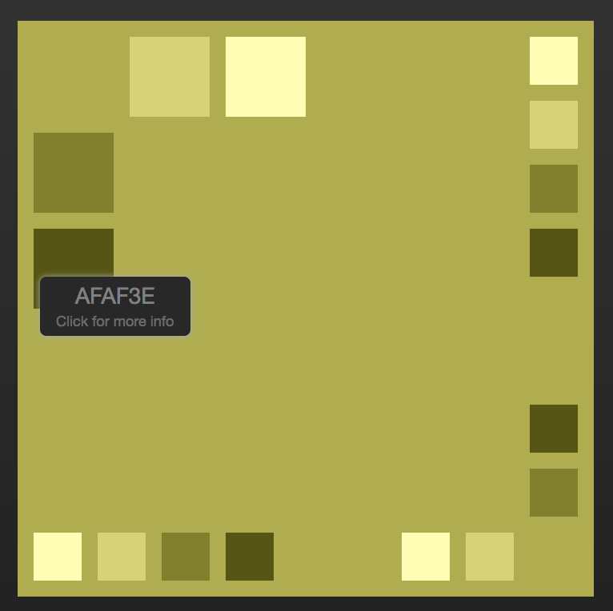

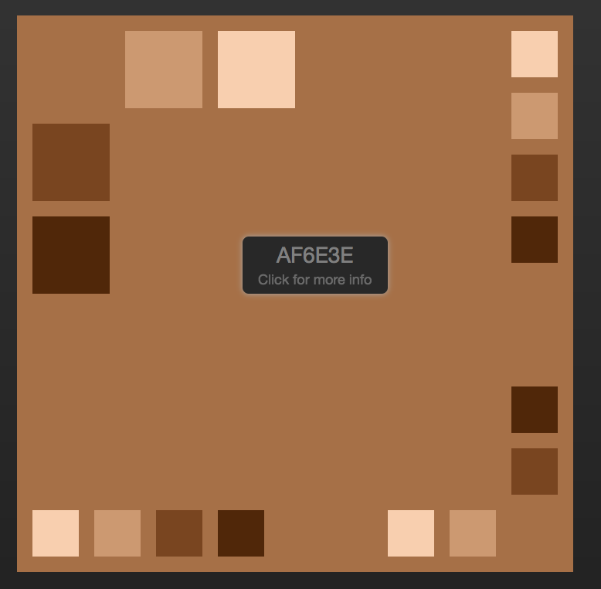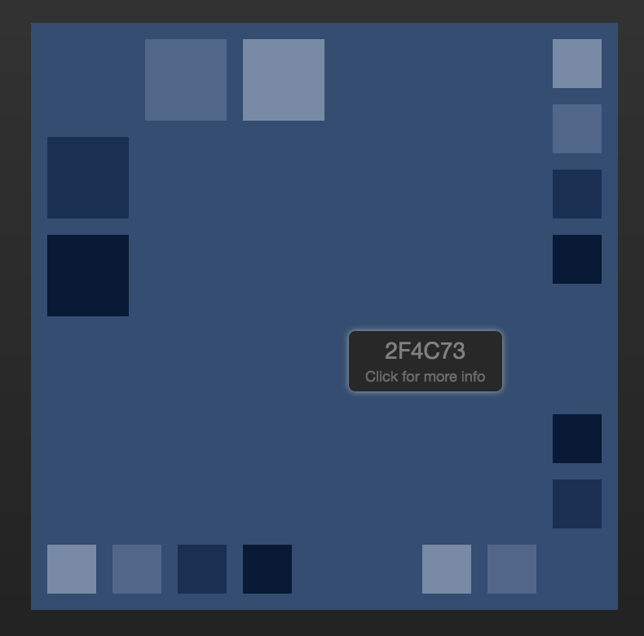

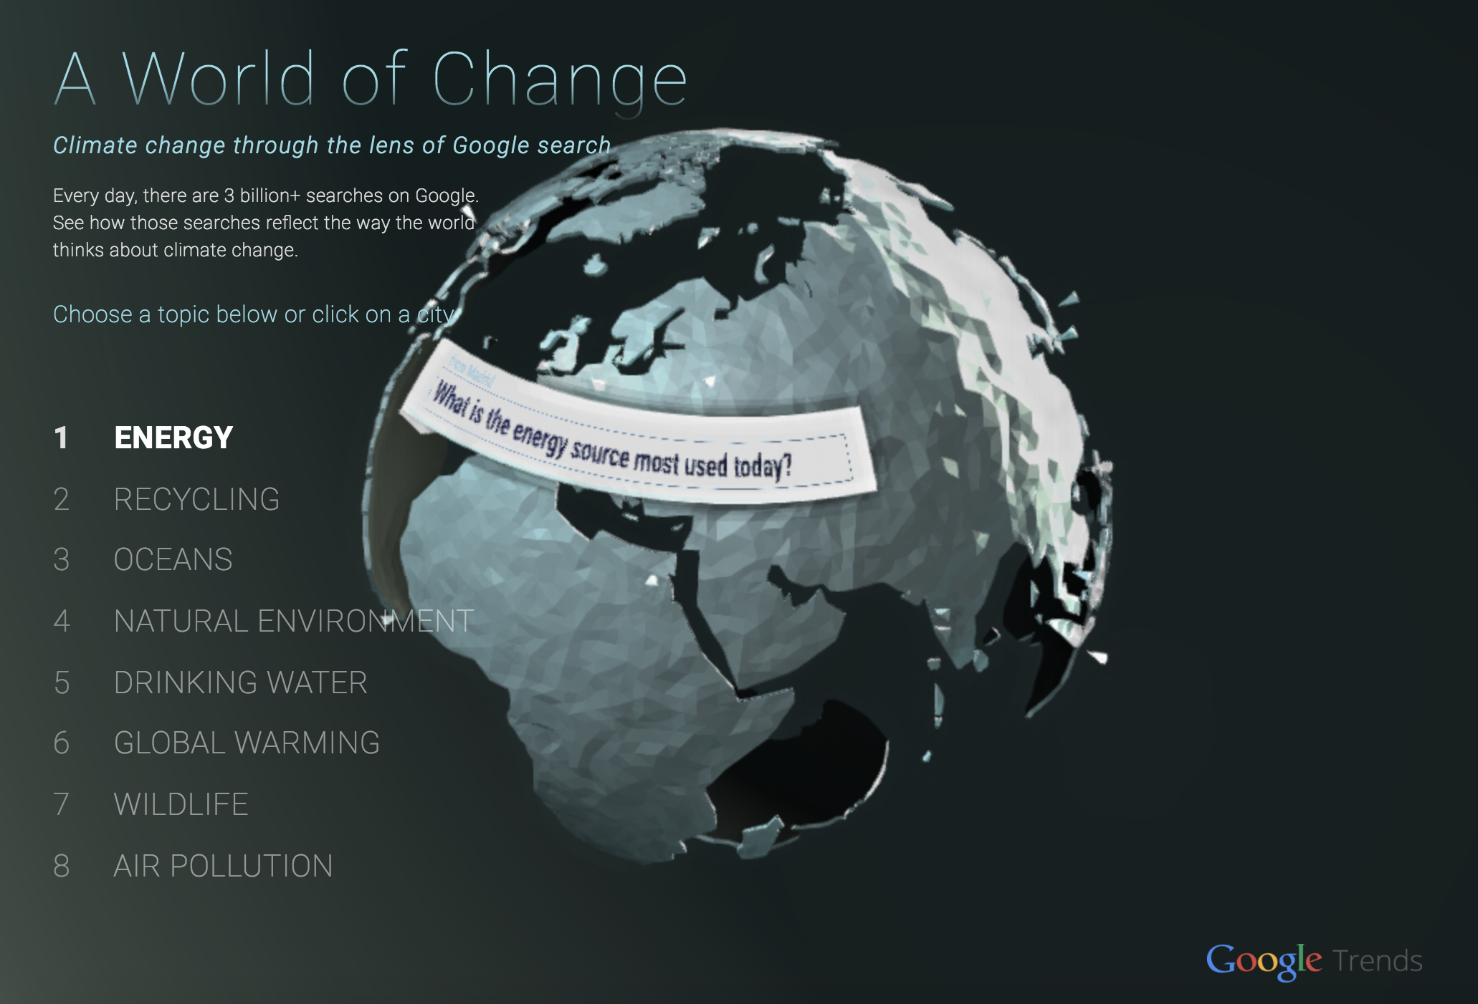

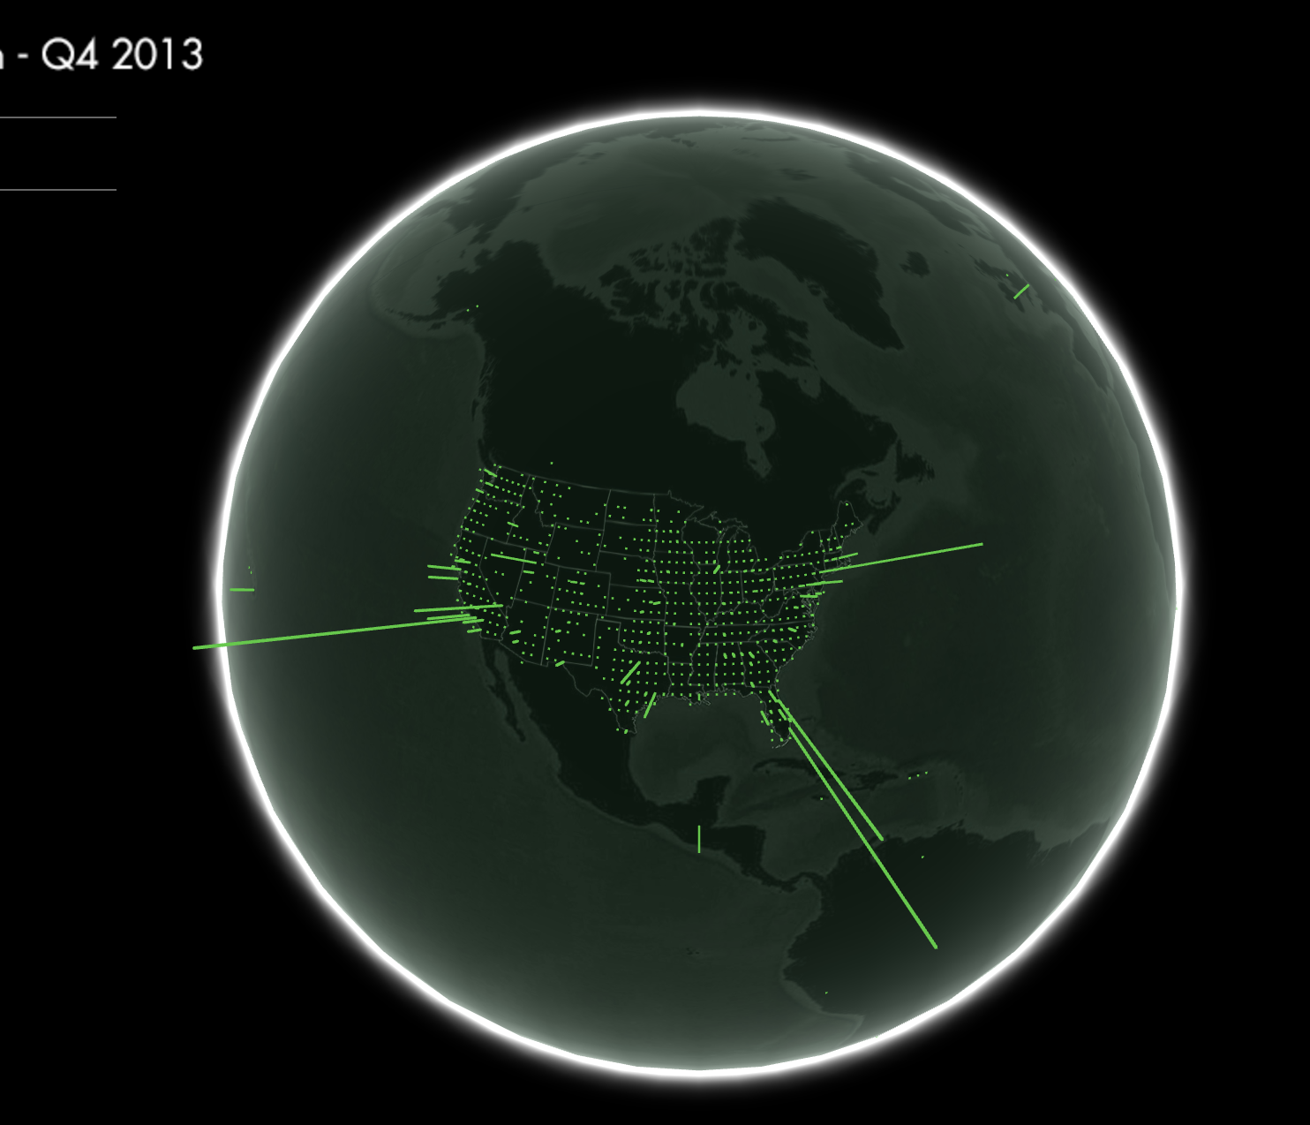

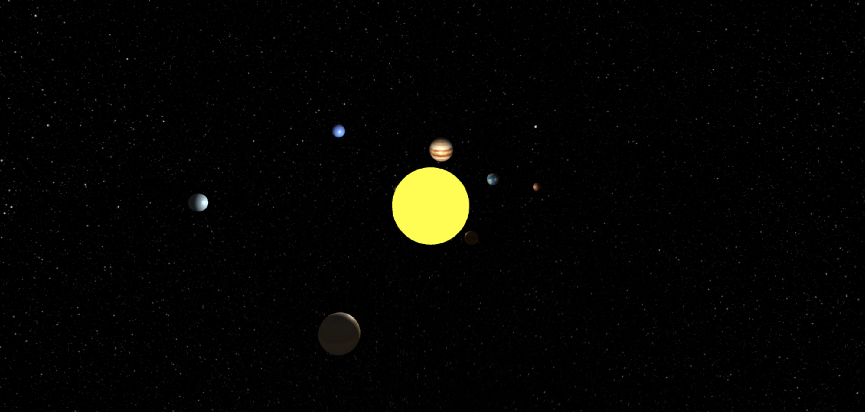

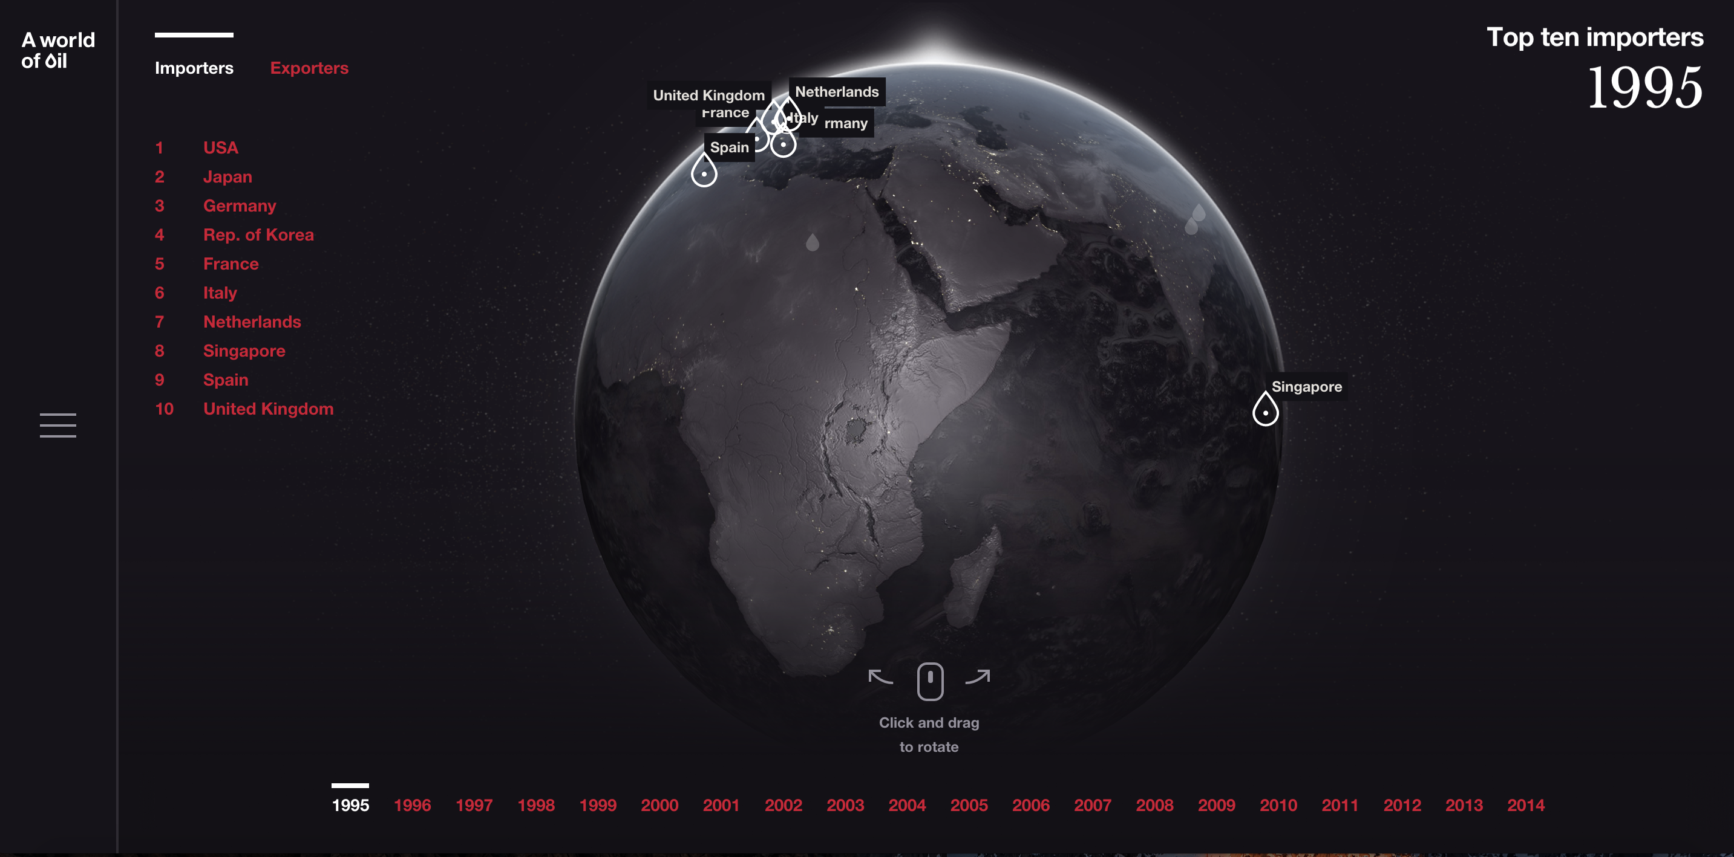

Questions:

1. What colors to use for the following items?

* Menu + Year: ??
* Universe: ??
* Earth: ??
* Pin: ??

Sample color schemes:

<http://paletton.com/#uid=11W0u0kkJlWaFv+f+qFqEg0v+aG>

1. How to keep earth and solar system consistent?